AccuRX/Florey Surveys for CCRs – Information Sheet

Guidance can be obtained here: [Florey] Cancer Care Review questionnaire: question and SNOMED codes | accuRx Help Center

- How the survey looks to the patient:

Content

Enrolment SMS
Hi/Dear NAME,
We will be inviting you in for a review with your doctor or nurse due to your cancer diagnosis. Please answer the following questions to make sure the review is as useful as possible.
Please complete this questionnaire: (link will autogenerate here)
Thanks,
Sender Name
Organisation Name
First page of questionnaire
Hi NAME,
Your practice will be inviting you in for a review with your doctor or nurse due to your cancer diagnosis. We would like to ask some questions in advance to ensure that the appointment is as useful as possible. Apologies if you feel we should have some of this information already but we want to make sure it is all up to date. This questionnaire will only take a few minutes.
Are you happy to proceed?
Powered by accuRx.

Questions
What is your date of birth?
Example 8 12 1988
- DD MM YYYY
Which of the following treatments have you received?
Choose all that apply (you can select none)
- Chemotherapy
- Radiotherapy
- Immunotherapy
- Surgery
- Hormone therapy
Are any of the following symptoms affecting your quality of life that you would like to discuss?
Choose all that apply (you can select none)
- Bowel/Bladder problems
- Tiredness
- Pain/Discomfort
- Sleep problems
- Appetite weight problems
- Sexual problems
- Other
(If the patient selects "Other")
What other symptoms are affecting your quality of life that you would like to discuss?
- Free text box
Are any of the following bothering you that you would like to discuss?
Choose all that apply (you can select none)
- Anxiety or low mood
- Concerns about work
- Worry about your loved ones/family
- Thinking about the future
- Concerns about finance
Your GP or nurse can be useful to discuss planning for the future. Is this something you would like the opportunity to do?
- Yes
- No
What is your smoking status?
- Current smoker
- Ex-smoker
- Never smoked
How much do you smoke? (only asked if patient selects current smoker)
- < 1 cigarette or equivalent per day
- 1-9 cigarettes or equivalent per day
- 10-19 cigarettes or equivalent per day
- 20-39 cigarettes or equivalent per day
- 40+ cigarettes or equivalent per day
Do you drink alcohol?
- Yes
- No (questionnaire ends)
How often do you have a drink containing alcohol? (If selected "yes" to previous question only)
- Never
- Monthly or less
- 2-4 times per month
- 2-3 times per week
- 4 or more times per week
When saved back to record - "Frequency of drinking alcohol: 2-4 times per month"
How many units containing alcohol do you drink on a typical day when you were drinking? (1 pint of beer is approximately two units, and one small glass of wine is 1 unit)
- 1 or 2 units (Light drinker - 1-2u/day - 160575005)
- 3 or 4 units (Moderate drinker - 3-6u/day - 160576006)
- 5 or 6 units (Moderate drinker - 3-6u/day - 160576006)
- 7 to 9 units (Heavy drinker - 7-9u/day - 160577002)
- 10 or more units (Very heavy drinker - greater than 9 units/day - 160578007)
When saved back to record - "Units of alcohol drunk on a typical day: 3-4 units"
How often did you have 6 or more units if female, or 8 or more if male, on a single occasion in the past year?
- Never
- Less than monthly
- Monthly
- Weekly
- Daily or almost daily
When saved back to record - "Drank greater than 6/8(F/M) units in the past year: Monthly"
What type and amount of activity is involved in your work?
- I am not in employment (e.g. retired, retired for health reasons, unemployed etc.)
- I spend most of my time at work sitting (such as in an office)
- I spend most of my time at work standing or walking. However, my work does not require much intense physical effort (e.g. shop assistant, hairdresser, security guard, childminder etc.)
- My work involves definite physical effort including the handling of heavy objects and use of tools (e.g. plumber, electrician, carpenter, cleaner, hospital nurse, gardener, postal delivery workers etc.)
- My work involves vigorous physical activity including handling of very heavy objects (e.g. scaffolder, construction worker, refuse collector, etc.)
During the last week, how many hours did you spend on physical exercise such as swimming, jogging, aerobics, football, tennis, gym, workout etc.
- None
- Some but less than 1 hour
- 1 hour but less than 3 hours
- 3 hours or more
Is there anything else you would like to discuss in your Cancer Care Review?
- Free text answer

Post-submission screen
Thank you for submitting your answers.
What next?
Your practice will now review the information in the next 28 days and contact you to arrange your Cancer Care Review appointment.
Macmillan Cancer Support
The Macmilan website has many resources to support you: https:/www.macmillan.org.uk/
The Macmillan telephone support line is available to answer any questions you might have about your cancer or how it is affecting your life. This is available 7 days a week, 8am-8pm: 0808 808 00 00
The Macmillan Online Community:
https://community.macmillan.org.uk
How the patient response looks like in the accuRx Inbox
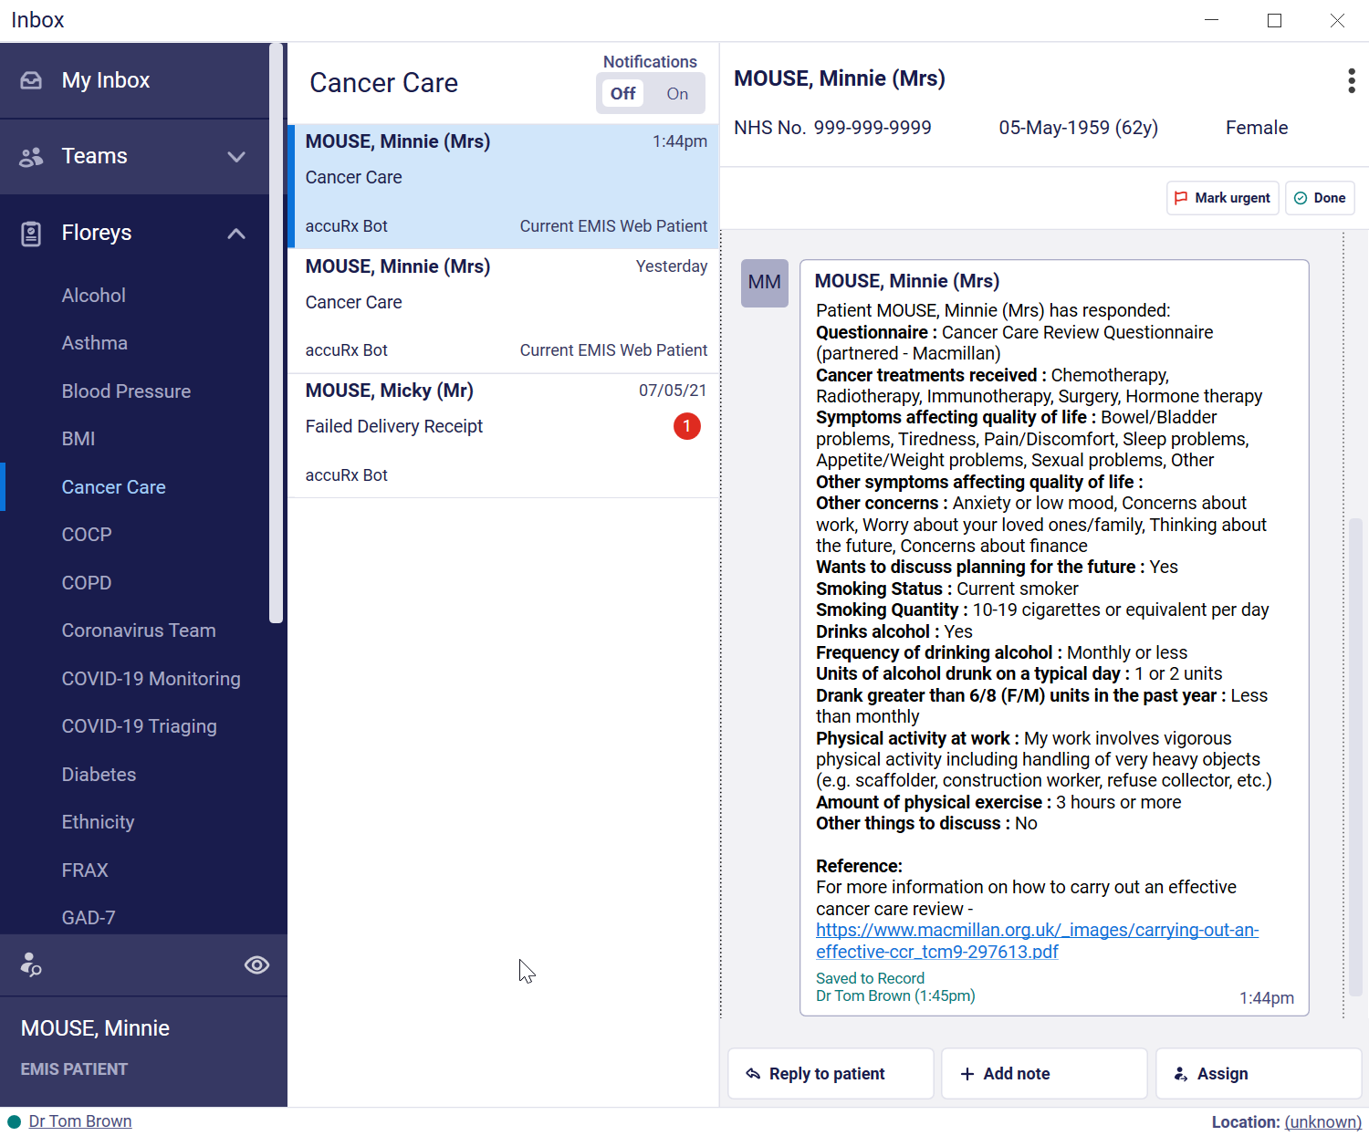
How the entry looks like saved into EMIS:
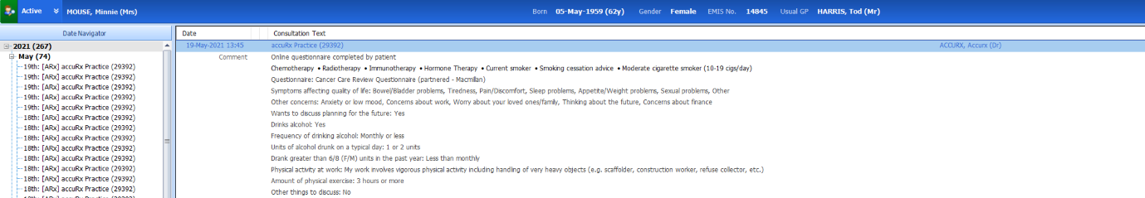

SNOMED Codes saved back to EMIS/SystmOne:
Chemotherapy 367336001
Radiotherapy 419815003
Immunotherapy 76334006
Hormone Therapy 169413002

This guidance is taken directly from the AccuRX site and whilst the focus below is on an Asthma review – the principle applies to whatever survey is needed.

- How the survey is initiated:
Florey lets you send a pre-made survey to patients, which they can fill out and the responses are then fed back to you via the accuRx Desktop toolbar.
You can then save these responses directly to the record! Some surveys even automatically save relevant SNOMED codes! 😊
Examples of some of the Florey Surveys that are available are:
- COVID-19 Remote Monitoring Questionnaire
- COVID-19 Triaging Questionnaire
- Asthma Questionnaire
- COPD Questionnaire-MRC
- Flu Vaccine Invite
- Alcohol Consumption Questionnaire - AUDIT-C*
- BMI Questionnaire*
- Smoking Questionnaire*
The example we have used for the purpose of this particular step-by-step guide is the Asthma Questionnaire. However, the other Florey Surveys work like this too.
📹 If you prefer a video of how Florey works, we've got one here.

Sending a questionnaire to a patient
Step 1:
Make sure you have both (1) EMIS/SystmOne and (2) the accuRx Desktop toolbar open, and select a patient (or a dummy patient if you want to give it a test for yourself).
Step 2:
Open up Message Patient by clicking the message icon in the middle of the toolbar.

Step 3:
Click on the Florey tab:
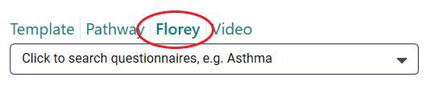
From the Florey tab, you can see the available surveys.
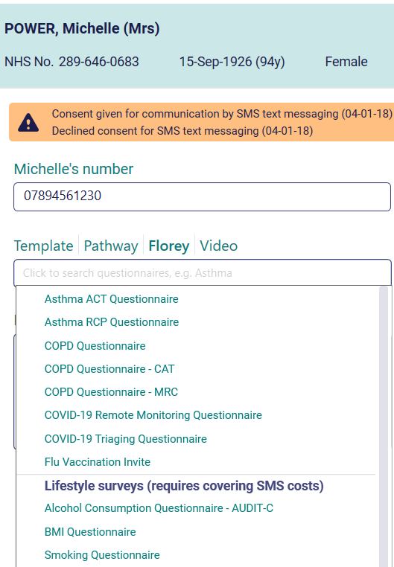
Step 4:
Click the survey you'd like to send to the patient, e.g. "Asthma Questionnaire", and the text message will pre-fill (but feel free to edit it to make it more personalised!)
Click the big blue button "Send and save" and the message will be on its way to the patient!
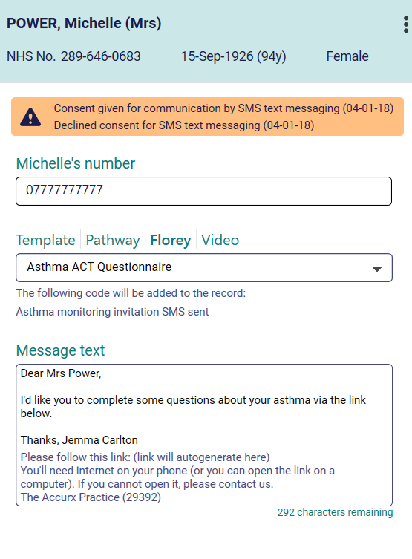

Reminders
Patients will receive a couple of extra texts if they have not completed the survey in the week following, before it times out at 7 days.
- Reminder 1, sent on day 3:
"You still need to complete your health questionnaire. This allows your practice to manage your health effectively and helps the NHS. You need internet on your phone (otherwise use a computer or contact reception). Please follow this link: (link generated here)"
- Reminder 2, sent on day 6:
"This is the last day for you to complete your health questionnaire before the link expires. You need internet on your phone (otherwise use a computer or contact reception). Please follow this link: (link generated here)"
Please note: the above reminders are worded for the asthma questionnaire. Similar reminders are sent for the other Florey Surveys with the exception of the COVID-19 Remote monitoring questionnaire (more details on that here).

Patient response
Here's a video which includes a patient view of the survey.

Processing questionnaire responses
Step 1:
When a new response comes back from a patient, you will see a notification on the Inbox icon of your accuRx Desktop toolbar.
Step 2:
Once you open the Inbox, you should navigate to the "Floreys" section and click on the Florey you want to view responses for (e.g. "Asthma Team". )
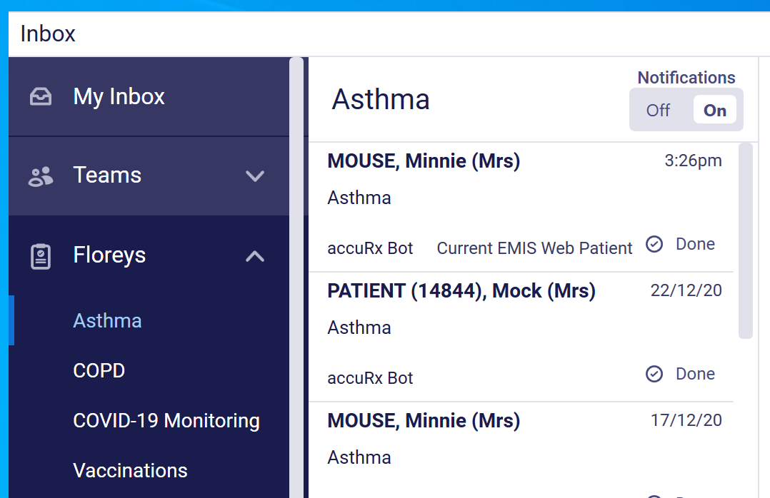
Step 3:
When you click on "Asthma Team" you will be see all patients that have responded to that the Asthma questionnaire in the central pane. When you click on one of the cards, you can see their response in the right-hand pane (new responses will have a red notification next to their name).
Step 4:
Under the patient's response, is a big button "Save to Record" - click on this to save the responses to the record.
For some Florey Surveys, SNOMED codes will be automatically saved to the record!
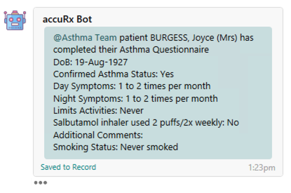
Note: if you would like to add the free text comment that the patient wrote in the survey to the medical record, you will need to go back in and manually copy&paste this from the message.

